

The spark counter

Demonstration
The spark counter is a highly visible (and audible) way of showing and counting ionisation of the air caused by alpha radiation (or a match). It is a useful step towards understanding the Geiger–Müller tube.

Apparatus and materials
- Power supply, EHT, 0–5 kV (with option to bypass safety resistor)
- Spark counter
- Sealed source of radium, 5 μC (if available) or sealed source of americium-241, 5 μC
- Holder for radioactive source (e.g. forceps)
- Connecting leads

Technical notes
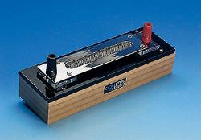
The spark counter is a special piece of apparatus (see image above). It consists of a metal gauze with a wire running underneath. Philip Harris calsl it a Spark discharge apparatus.
Any kink or bend in the wire in the counter is liable to cause a spark discharge at that point. If that happens the wire should be replaced. A continuous spark (which will very soon damage the wire) shows that the voltage is too high.
The spark counter should be dust free. Dust around the stretched wire can usually be blown away.
The gauze on top is connected to earth on the EHT supply as a safety precaution.
Radium is a source of alpha, beta and gamma radiation. Beta and gamma radiation do not cause enough ionisation of the air to start a spark.

Safety
See guidance note on Managing radioactive materials in schools.
A school EHT supply is limited to a maximum current of 5 mA, which is regarded as safe. For use with a spark counter, the 50 MW safety resistor can be left in circuit, thus reducing the maximum shock current to less than 0.1 mA.
Although the school EHT supply is safe, shocks can make the demonstrator jump. It is therefore wise to see that there are no bare high voltage conductors. Use female 4 mm connectors where required.
Read our health and safety statement.

Procedure
Setting up
a Connect the positive, high-voltage terminal of the spark counter to the positive terminal of the EHT supply without the 50 MW safety resistor. (The spark counter’s high-voltage terminal is joined to the wire that runs under the gauze.)
b Connect the other terminal on the spark counter to the negative terminal of the power supply and connect this terminal to earth.
c Turn the voltage up slowly until it is just below the point of spontaneous discharge. This is usually at about 4500 V.
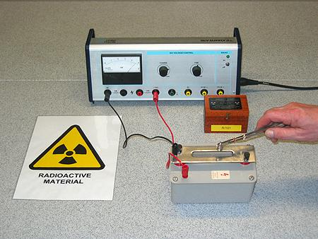
Photo courtesy of Mike Vetterlein.
Carrying out
d Use forceps to hold a radioactive source over the gauze. You should see and hear sparks jumping between the gauze and the high-voltage wire underneath, each time an alpha source is brought near to the counter.
e Move the source slowly away from the gauze and note the distance at which it stops causing sparks.

Teaching notes
1 Draw attention to the random nature of the sparks and hence of the radiation. By counting sparks you are counting the number of alpha particles emitted.
2 You should find that the range of the alpha particles is about 5 cm.
3 You could mention that this is alpha radiation, which is the most ionising of the three main types of radiation.
4 The sparks are similar to those produced by the Van de Graaff. The alpha particles ionise the air, forming positive and negative ions. When these recombine to form neutral atoms, blue light is emitted. The noise of the spark is due to warming the air in the narrow region of the avalanche current, producing a sound wave just like in a lightning strike.
5 A thin sheet of tissue paper or gold foil held between the spark counter and the source will show a reduced range for the alpha particles, or even prevent them from getting to the counter.
6 A version of this apparatus can be seen in the CERN visitor centre (if you happen to be passing). It detects cosmic rays and makes them visible using a 3D array of wire meshes with high voltages between them. The paths of rays can be seen by the trail of sparks that they leave as they ionise the air between the wire meshes. This type of 3D array of high-voltage meshes is the principle used to detect the paths of particles produced in the collision experiments at CERN.
7 Before you use the spark counter showing ionisations from an alpha source, you could use it to count matches (as in Counting matches with an EHT supply, which can be found on the Practical Physics website)
This experiment was safety-tested in June 2007.
Related guidance notes
- Managing radioactive materials in schools
- First models of the atom

